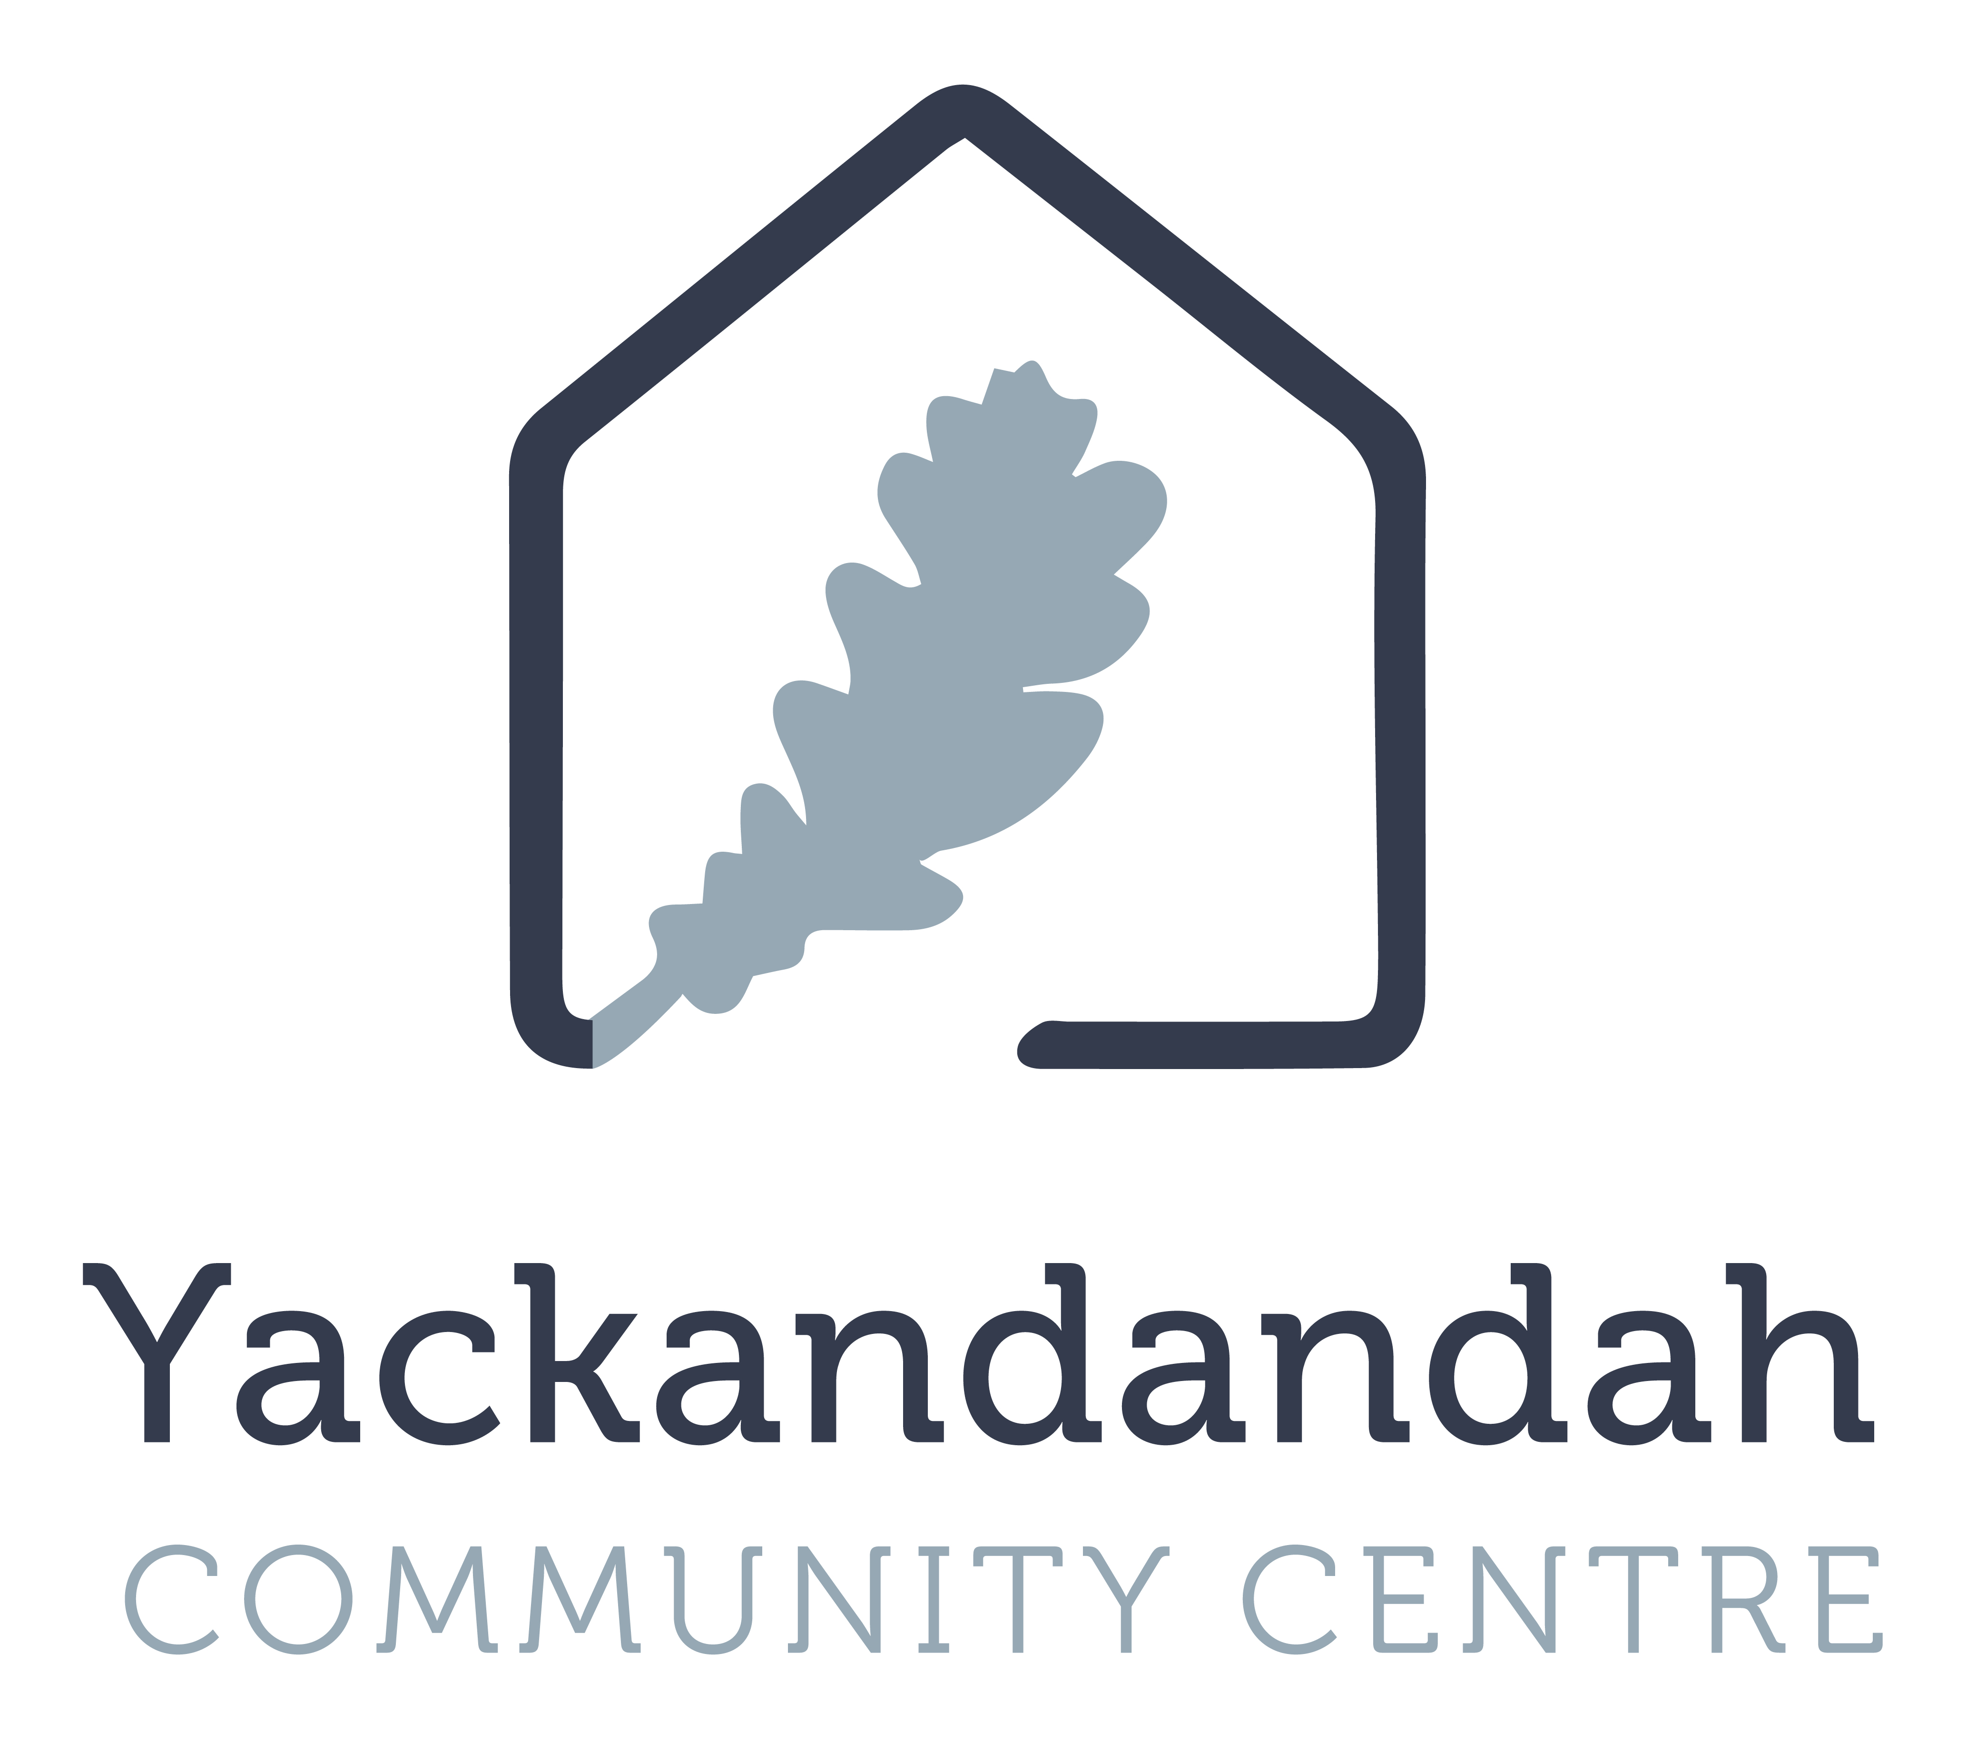
YACKANDANDAH COMMUNITY CENTRE
Community Grants Program 2024
The Yackandandah Community Centre (YCC) – Community Grants program is part of the Yackandandah community op-shop social enterprise. Annual profits made by the community op-shop are distributed back into the community via the community grants program.

Grant Guidelines
YCC prioritise projects which aim to create ongoing benefits to Yackandandah, build community capacity and create positive change for the Yackandandah Community.
YCC is offering grant funding to local community groups up to a maximum value of $3,000.

Application requirements
- YCC will only accept one application per organisation per year.
- If your project involves more then one organisation than, you must nominate one organisation that will manage the project and accept the grant funding on behalf of the project group.
- Grant funding will not be awarded to individuals, you must be in collaboration with a local community group or organisation.
- We can provide seed funding for projects that build capacity and help create structural change and have the potential to continue after the funding period.
- Grant funding amounts will be decided by the YCC Management Committee based on eligibility criteria.
- Full requested amount is not guaranteed. Fund allocation will depend on the amount available for grants and the number of applications and amounts requested.

Eligibility
To be eligible for a community grant, you must demonstrate though your application that your project will show one or more of the following criteria;
- Make a significant contribution to the Yackandandah Community
- Create opportunities for innovation and new ways of doing things
- Encourage inclusion and provide equal opportunities for all
- Enhance community self-resilience, including equipment
- Improve community well-being
- Offer learning opportunities
- Initiatives based on current climate science

Ineligibility
The Yackandandah Community Centre does not fund;
- Projects that do not meet the grant aim and eligibility of the YCC grants program
- The core operating costs of existing organisations
- Vehicles
- Food parcels, crisis, or emergency response
- Deficit funding
- Projects that will rely on recurrent funding from YCC
- Other philanthropic foundations or individuals

Application Due date:

Applications must be submitted by 4pm, Thursday April 18th 2024.

Application can be submitted by the following:

Sent by Email (preferred):
Attention: Jane Murphy (Manager)
Send to manager@ycc.org.au

Delivered by Hand:
Yackandandah Community Centre - Office
29 High Street, Yackandandah
Tue, Wed, Thur between 9am-4pm

Sent By Mail:
Yackandandah Community Centre
PO Box 702
Yackandandah, Vic 3749

If you do not receive an email confirmation that we have received your application within seven days of submitting, please call our office on 02 3027 1743. It is your responsibility to ensure that your submission has been received.
Application Form_Yackandandah Community Centre Grants 2024

- Name of project / initiative that you are seeking a grant for?

Contact details:
- Name & Details of group/organisation managing the project.
Group Name:
Postal Address:
Phone Number:
Email:
Website:
Social media tags:
Legal Status:
ABN:
If your organisation is unincorporated OR does not hold a valid current ABN, you must nominate an auspice organisation, see question 3.

- If required, Name and details of the Auspice organisation.

Name:
Postal Address:
Phone Number:
Email:
Website:
Social media tags:
Legal Status:
ABN:

- Name and details of the two primary contacts for the project.
 | Primary Contact | Second Contact
Name:
Email:
Phone No.:
Postal Address:
Note:

- If your organisation does not have a website, please provide a brief history and purpose of your organisation.

Project Overview
- What amount of funding are you seeking from Yackandandah Community Centre? (maximum amount $3000)

- If YCC is only able to provide a part of the amount requested, will the project / initiative still be able to go ahead?
Yes | No
Please add comments:

- Describe the project / initiative
Project description:

Who will it benefit?
Start date: (if applicable)
End date: (if applicable)
Location:
Expected outcome:
- If applicable, please add supporting documentation;
- Pictures / images to help describe items/equipment/project
- Quotes and or breakdown details of costs/expenses
- Support letters

- If applicable, how do you plan to make this project sustainable after the funding period?

Please ensure that all applicable questions are completed as incomplete submissions may not be eligible for funding.
Submissions are due by 4pm, Thursday April 18th, 2024.

Completed applications must be submitted to the YCC Manager.
Attention; YCC Manager, Jane Murphy
Send by Email (preferred):  Send to manager@ycc.org.au | Deliver by Hand:  Yackandandah Community Centre - Office  29 High Street, Yackandandah  Tue, Wed, Thur between 9am-4pm | Send By Mail:  Yackandandah Community Centre  PO Box 702  Yackandandah, Vic 3749

End of application.

